Salinity
Did you ever wonder why the oceans are filled with salt water instead of fresh? Just where did the salt come from? And is it the same salt you find on a dining room table? Most of the salt in the oceans came from land. Over millions of years, rain, rivers, and streams have washed over rocks containing the compound sodium chloride (NaCl), and carried it into the sea. You may know sodium chloride by its common name: table salt! Some of the salt in the oceans comes from undersea volcanoes and hydrothermal vents. When water evaporates from the surface of the ocean, the salt is left behind. After millions of years, the oceans have developed a noticeably salty taste.
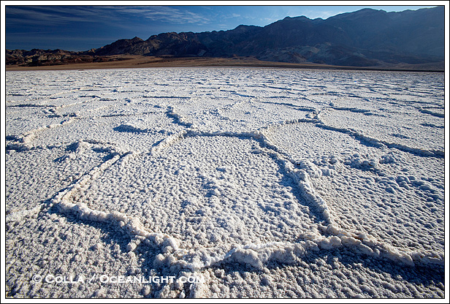
Different bodies of water have different amounts of salt mixed in, or different salinities. Salinity is expressed by the amount of salt found in 1,000 grams of water. Therefore, if we have 1 gram of salt and 1,000 grams of water, the salinity is 1 part per thousand, or 1 ppt.
The average ocean salinity is 35 ppt. This number varies between about 32 and 37 ppt. Rainfall, evaporation, river runoff, and ice formation causes the variations. For example, the Black Sea is so diluted by river runoff, its average salinity is only 16 ppt.
Freshwater salinity is usually less than 0.5 ppt. Water between 0.5 ppt and 17 ppt is called brackish. Estuaries (where fresh river water meets salty ocean water) are examples of brackish waters.
Most marine creatures keep the salinity inside their bodies at about the same concentration as the water outside their bodies because water likes a balance. If an animal that usually lives in salt water were placed in fresh water, the fresh water would flow into the animal through its skin. If a fresh water animal found itself in the salty ocean, the water inside of it would rush out. The process by which water flows through a semi-permeable membrane (a material that lets only some things pass through it) such as the animal's skin from an area of high concentration (lots of water, little salt) to an area of low concentration (little water, lots of salt) is called osmosis.
This is also why humans (and nearly all mammals) cannot drink salt water. When you take in those extra salts, your body will need to expel them as quickly as possible. Your kidneys will try to flush the salts out of your body in urine, and in the process pump out more water than you are taking in. Soon you'll be dehydrated and your cells and organs will not be able to function properly.

Pressure
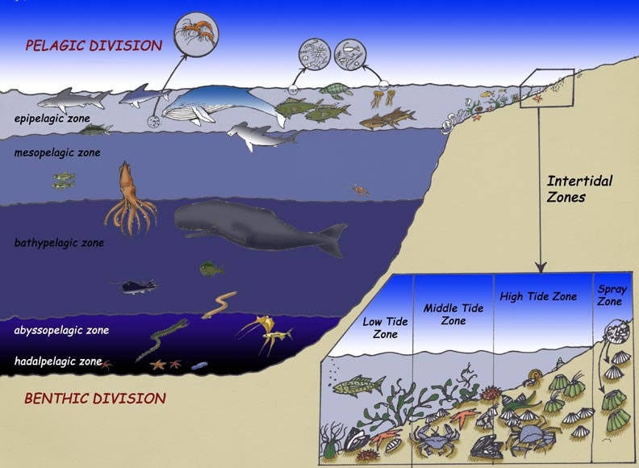
Even though we do not feel it, 14.7 pounds per square inch (psi), or 1kg per square cm, of pressure are pushing down on our bodies as we rest at sea level. Our body compensates for this weight by pushing out with the same force.
Since water is much heavier than air, this pressure increases as we venture into the water. For every 33 feet down we travel, one more atmosphere (14.7 psi) pushes down on us. For example, at 66 feet, the pressure equals 44.1 psi, and at 99 feet, the pressure equals 58.8 psi.
To travel into this high-pressure environment we have to make some adjustments. Humans can travel three or four atmospheres and be OK. To go farther, submarines are needed.
Animals that live in this watery environment undergo large pressure changes in short amounts of time. Sperm whales make hour-long dives 7,380 feet (2,250 meters) down. This is a pressure change of more than 223 atmospheres! By studying and understanding how these animals are able to withstand great pressure changes, scientists will be able to build better tools for humans to make such journeys.

Density and Layers
Temperature, salinity and pressure work together to determine water density (weight of water divided by the amount of space it occupies). Cold, salty water is much denser than warm, fresher water and will sink below the less dense layer.
The ocean waters can be divided into three layers, depending on their densities. Less dense waters form a top layer called the surface mixed zone. The temperature and salinity of this layer can change often because it is in direct contact with the air. For example, water evaporation could cause an increase in salinity, and a cold front could cause a drop in temperature.
The next layer is the pycnocline, or transition zone. The density here does not change very much. This transition zone is a barrier between the surface zone and a bottom layer, allowing little water movement between the two zones.
The bottom layer is the deep zone, where the water remains cold and dense. The polar regions are the only places where deep waters are ever exposed to the atmosphere because the pycnocline is not always present.

Temperature
The ocean has a wide range of temperatures from the almost 100°F (38°C) shallow coastal waters of the tropics to the nearly freezing waters of the poles.
The freezing point of seawater is about 28.4°F (-2°C), instead of the 32°F (0°C) freezing point of ordinary water. Why do you think the freezing points are different? Right, because seawater has salt in it! As seawater increases 5 ppt in salinity, the freezing point decreases by 0.5°F.
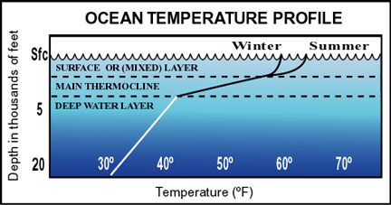
From "Ocean Talk" by Naval Meteorology and Oceanography Command
The ocean can be divided into three vertical zones, depending on temperature. The top layer is the surface layer, or mixed layer. This layer is the most easily influenced with solar energy (the sun's heat), wind and rain. The next layer is the thermocline. Here the water temperature drops as the depth increases. The last layer is the deep-water layer. Water temperature in this zone decreases slowly as depth increases. Water temperature in the deepest parts of the ocean is averages about 36°F (2°C).

Acoustics
Water is an excellent sound conductor. This means that water does not absorb sound, so it can travel for great distances before it dies out. The speed of sound in the water is 4,750 to 5,150 feet (1,448 to 1,570 meters) per second. This time increases by 7 feet (2 meters) per second whenever the temperature increases by 1° degree F.
Though Jacques-Yves Cousteau once dubbed the ocean "the silent world," we now know that is not exactly true. The ocean is full of sound. Our ears just aren't specialized enough to hear all the different frequencies.
Ocean animals make noise all the time. They make noise while swimming, when they are frightened, to find food, to send out warnings, to check out their surroundings and to talk to each other.
Dolphins and some whales use a process called echolocation. First, they send out a series of clicks and whistles and then listen for echoes as the sounds bounce off objects, such as other fish, boats, the ocean floor or reefs, in their path. From the direction and strength of the echo, these animals can develop a mental image of their environment. They can "see" the size of objects in their path and how far away the objects are.
The sonar we use to study the ocean floor works like echolocation. By sending out signals and retrieving the echoes, we can develop pictures of all the features on the ocean floor. We can also find objects on the bottom, like shipwrecks or mines, and in the water column, like submarines or large schools of fish.
Scientists found one part of the ocean that conducts sound a bit differently from the rest. It is called the SOFAR channel, which stands for SOnic Fixing And Ranging Channel. Low-frequency sounds can travel for hundreds of miles in this channel. Any shallower or deeper in the water column the sound will fade out much faster.

Optics
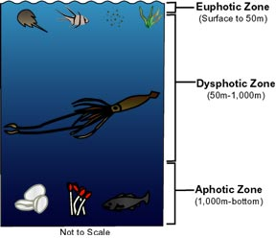
Most of the organisms in the ocean depend on sunlight. Plants and bacteria, such as kelp, seagrass and photosynthetic plankton, use light to make energy through a process called photosynthesis. These are then eaten by larger animals, which are in turn eaten by larger animals and so on. Remember the food chain? Sunlight is the basis (beginning) for this food chain. Sunlight also warms the ocean's surface. This is important because it makes the water warm enough for animals to live in it, and it is a driving force for some currents.
As sunlight enters the ocean, it starts to be absorbed. The ocean can be broken down into three vertical zones based on how much light it receives. The first zone, or euphotic zone, extends from the water's surface to about 50 meters depth, depending on the time of year, the time of day, the clarity (clearness) of the water and the presence of clouds. This is the part of the water column where there is still enough light for plants to photosynthesize. All plankton, kelp forests and seagrass beds are found in the euphotic zone.
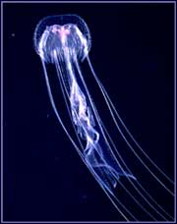
The next zone is the dysphotic zone, which extends from about 50 meters, or wherever the euphotic zone ends, to about 1,000 meters. In this zone, there is enough light for an organism to see, but it is too weak for photosynthesis to happen. If we were to venture into the dysphotic zone, we could watch the visible light disappear as we traveled deeper. Once we reached the aphotic zone, there would be no light. This zone extends from about 1,000 meters depth to the ocean bottom. Animals in this zone are rare, but they do exist. Think about the thriving hydrothermal vent communities, which live and prosper without sunlight.
Some animals in the aphotic zone create their own light. This is called bioluminescence.

Oceans of the World

Arctic Ocean – This is the northernmost ocean on Earth and surrounds the North Pole.

Atlantic Ocean – The 2nd largest ocean on Earth is located between the Americas and Europe and Africa.

Indian Ocean – This ocean is located off the coast of India and between eastern Africa and Australia.

Pacific Ocean – The largest ocean on Earth is located between Asia and the Americas.

Southern Ocean – This newly designated ocean surrounds Antarctica in the Southern Hemisphere.

Caribbean Sea – This large sea located off the coast of Central America.

Mediterranean Sea – This large sea is almost completely surrounded by northern Africa and Southern Europe.

Black Sea – This is an inland sea located in Eastern Europe and Russia.

North Sea – This sea is the northernmost of all major seas and connects England to Scandinavia.

Arabian Sea – This large sea is found east of Africa and runs to the west coast of India.

Red Sea – This long, thin sea runs between the Mediterranean and Arabian Seas.

Intro to Oceanography Name _______________________________

Salinity
1. What two sources provide salts in the ocean?

2. Have the Earth’s oceans always had the same salinity? Why or why not?

3. What is brackish water? Where does brackish water occur?

4. Why can’t saltwater fish live in freshwater? Why can’t freshwater fish live in saltwater?

5. Why can’t humans drink saltwater?

Temperature
6. What is the average freezing point of seawater? Why does seawater have a lower freezing point than freshwater?

7. At what rate does the freezing point of saltwater decrease with a change in salinity? If the maximum salinity of water is 359ppt, what is the lowest possible freezing point of saltwater?

8. Why does the surface layer experience temperature changes during different seasons, but the thermocline and deep water layers does not?

Density and Layers
9. What is the relationship between salinity, temperature, and density?

10. What are the three layers of the ocean based on density?

11. Which layer is the most variable in density? Explain why.

Pressure
12. What is an atmosphere (the measurement of pressure)? How many feet in water depth are in one atmosphere?

13. What is the deepest a human can go in the ocean freely without injury in atmospheres, feet and psi?

Acoustics
14. If sound travels 1,126 ft/s through air, how much faster will sound travel underwater over 10000 feet than through the atmosphere?

15. What is echolocation? How does it differ from SONAR?

16. What is the SOFAR Channel? How might whales and other marine life use this channel to benefit communication?

Optics
17. Why is most marine life found in the euphotic zone?

18. Which zone would you consider a zone of transition? Explain.

19. Where might animals live in the aphotic zone? Why would they live in this location?

20. Without sunlight in the aphotic zone, are animals here unable to see? Explain.

Oceans of the World – Use the names and descriptions of the oceans that are shown on the information sheet to label the map below

