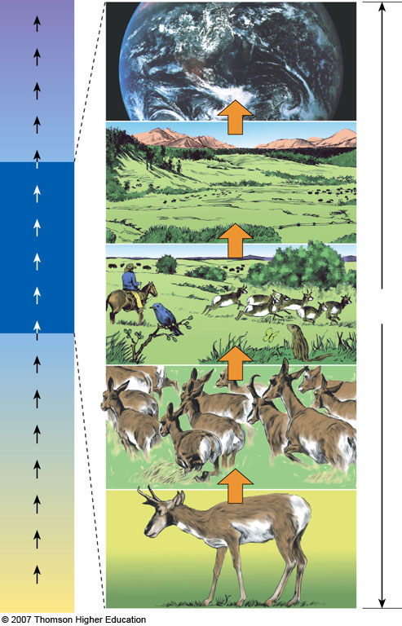

Range of tolerance to physical & chemical (abiotic) factors
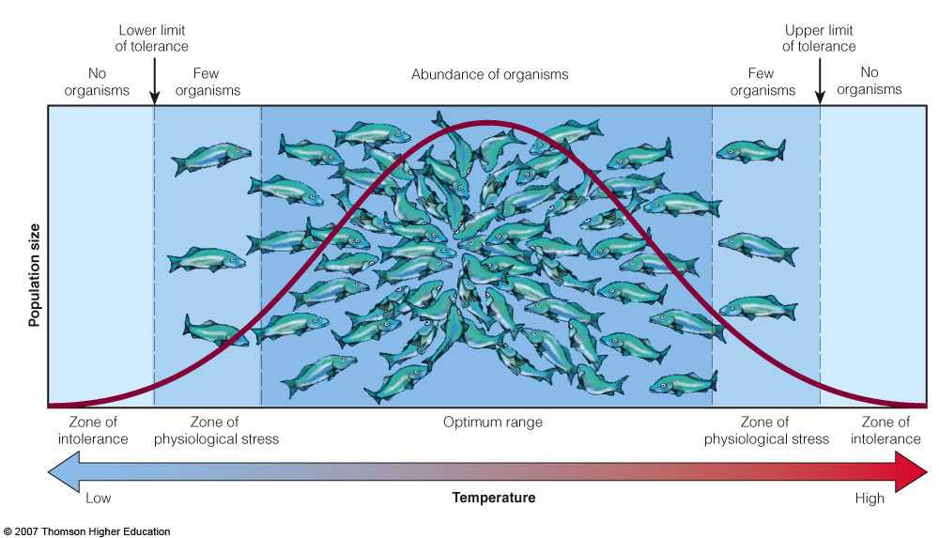
Limiting factors can include precipitation, soil nutrients, sunlight, salinity, etc.

