Feedback Mechanisms Name
How do organisms regulate complex systems through chemical interactions?
The heating system of a house works to keep the temperature constant. If the house gets too cold, then the heat automatically turns on to warm the house. The heat stops when the preset temperature is reached. This is an example of a feedback mechanism. Organisms use many feedback mechanisms to either maintain or amplify important chemical systems. This could happen at a molecular level to coordinate the function of a single enzyme or it could happen throughout the body to regulate the organism’s internal temperature.

Model 1 – Positive and Negative Feedback

Signal is sent. Signal is sent.

Stimulus
Negative
Feedback

Response

Stimulus
Positive
Feedback

Response

Stimulus is decreased. Stimulus is increased.

1. What two types of feedback mechanisms are illustrated in Model 1?

2. Define the words below as they are used in everyday language.

Stimulus Signal Response
3. Identify at least three similarities in the two types of feedback mechanisms in Model 1.

4. Imagine that you have just gotten a puppy. In the course of playing with the puppy you throw a ball and the puppy chases after it. You then say “Good job!” and rub the puppy’s head to show him he did what you wanted him to do.

a. Is the puppy likely to chase the ball the next time you throw it? Justify your reasoning.

b. Identify the portions of the scenario as stimulus or response.

Puppy chases the ball.

“Good Job” and head rub.

c. Is this scenario an example of positive or negative feedback? Justify your reasoning using the words “stimulus” and “response.”

5. Later that day your puppy urinates on the couch. You then say “No, bad dog!” and place the puppy outside.

a. Is the puppy likely to urinate on the couch again? Justify your reasoning.

b. Identify the portions of the scenario as stimulus or response.

Puppy urinates on the couch.
“No, bad dog!”
c. Is this scenario an example of positive or negative feedback? Justify your reasoning using the words “stimulus” and “response.”

6. Which of the feedback mechanisms in Model 1 would be most useful for amplifying a condition that is advantageous for the organism?

7. Which of the feedback mechanisms in Model 1 would be most useful for stopping a condition that is detrimental or limiting a condition to specified levels?

Model 2 – Thermoregulation in Humans

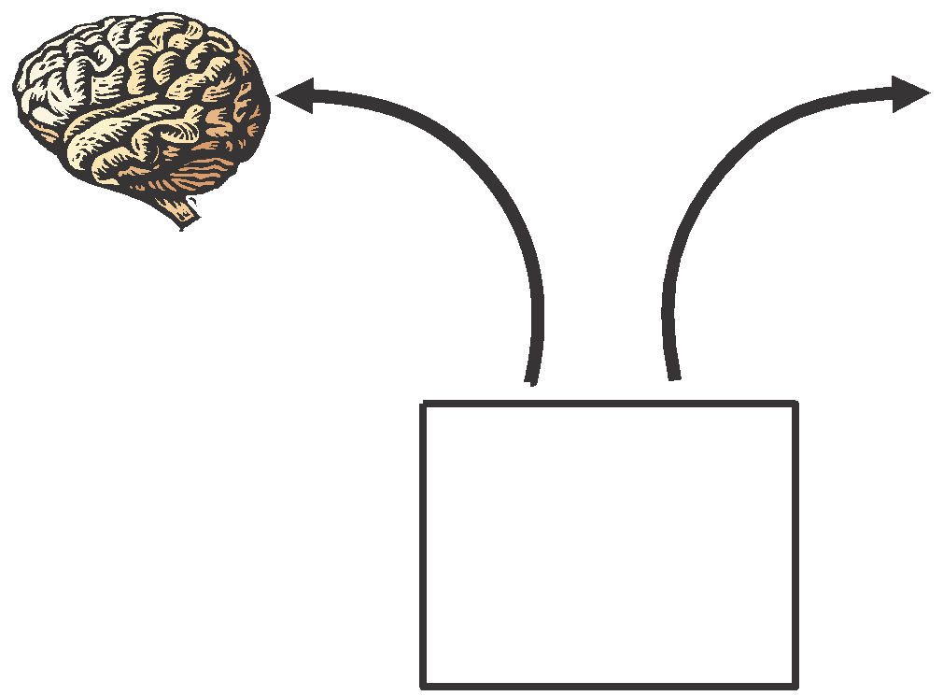
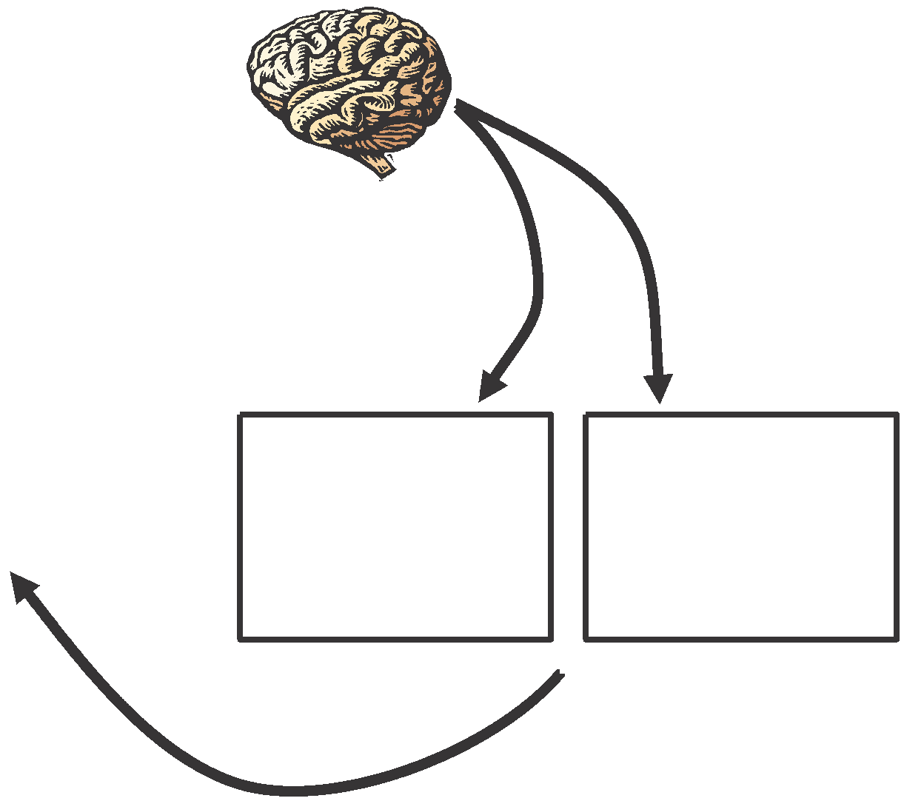
Hypothalamus senses that temperature is too low. Sends out signals
to heat the body.
Temp.
too low.

Temp. too high.

Hypothalamus senses that temperature is too high. Sends out signals to
cool the body.

Normal Body Temp.
36-38 degrees C

Muscles begin to shiver, generating heat.
Blood vessels in skin dilate to radiate heat.
Sweat glands increase sweat production
Blood vessels in skin constrict, reducing heat loss.

Body temperature decreases.
Body temperature increases.

8. Examine Model 2. Based on what you see in the model, propose a definition for “thermoregulation.”

9. According to Model 2, what portion of the brain contains sensors that monitor body temperature?

10. According to Model 2:

a. What are two mechanisms the body uses to cool itself?

b. What are two mechanisms the body uses to heat itself?

11. Consider the feedback loop that cools the body when it is too warm.

a. Identify the “stimulus” and “response” in the feedback loop.

b. Is this feedback loop positive or negative feedback? Justify your reasoning.

12. Consider the feedback loop that heats the body when it is too cold.

a. Identify the “stimulus” and “response” in the feedback loop.

b. Is this feedback loop positive or negative feedback? Justify your reasoning.

Read This!

Many of the systems in the body are delicate. They function only under a specific range of parameters. Enzymes will denature if they get too hot or cold or if the pH of the solution they are in is too high or too low. Cells will not be able to process glucose for energy if the concentrations of oxygen in the blood are not high enough. Feedback mechanisms are used to keep the body in homeostasis. That is, many systems are in place that monitor and regulate important parameters of the body and keep them within normal levels.

13. Consider the state of homeostasis—maintaining conditions within certain limits. The body needs multiple mechanisms to keep all types of systems in check.

a. Would a positive feedback loop ever be helpful in maintaining homeostasis? Justify your reasoning.

b. Would a single negative feedback loop ever be helpful in maintaining homeostasis? Justify your reasoning.

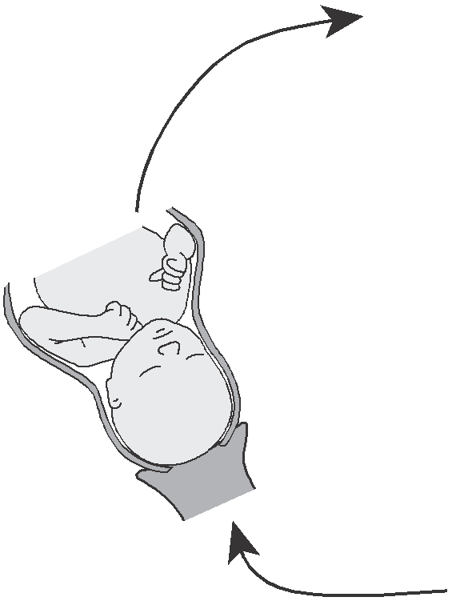
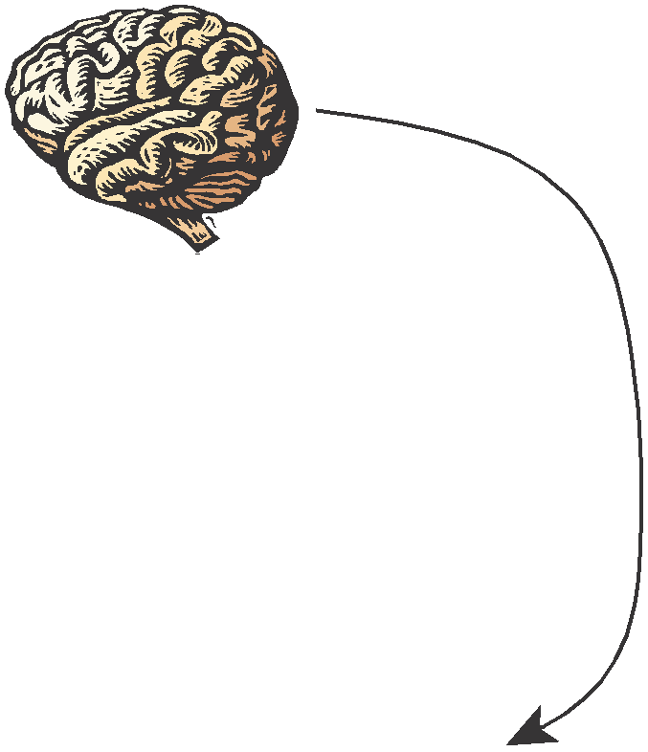
Model 3 – Childbirth and Contractions

Hypothalamus releases oxytocin.

Baby pushes against the cervix.

Uterine walls contract.

14. According to Model 3, what is the stimulus and what is the response during childbirth?

15. What hormone, released from the hypothalamus, increases the intensity of contractions?

16. When the intensity of contractions increases, will the stimulus increase or decrease?

17. Is childbirth an example of a positive or negative feedback system? Justify your answer.

18. What will eventually stop the stimulus and thus stop the childbirth feedback loop?

19. Below are several descriptions of processes that occur in the human body. For each one identify the stimulus and the response and state whether the process is positive or negative feedback.

a. When human tissue, such as skin or a blood vessel, is torn or cut, the cells near the damage send out a signal that activates platelets in the vicinity. As the platelets begin to form a plug, they release more chemical signals to attract more platelets and other clotting factors until the bleeding is stopped.

b. When a person has not taken in sufficient water they become dehydrated. This may cause a loss of blood pressure, which will trigger the release of antidiuretic hormone (ADH) from the hypothalamus and pituitary glands. This hormone signals the kidney to allow reabsorption of water by the blood vessels to bring the blood pressure back to normal conditions.

c. When a human increases physical activity, the amount of fuel burned in its cells also increases, which in turn increases the concentration of dissolved CO2 in the blood. The CO2 reacts with water in the blood to make a weak acid, which lowers the pH of the blood. Sensory cells in the medulla of the brain register this drop in pH and send signals to the diaphragm and heart to increase respiration. This will clear the CO2 from the bloodstream.

20. Draw a diagram similar to Models 2 and 3 for one of the feedback mechanisms in Question 19.

21. Relate the common phrase “a vicious cycle” to feedback loops.

